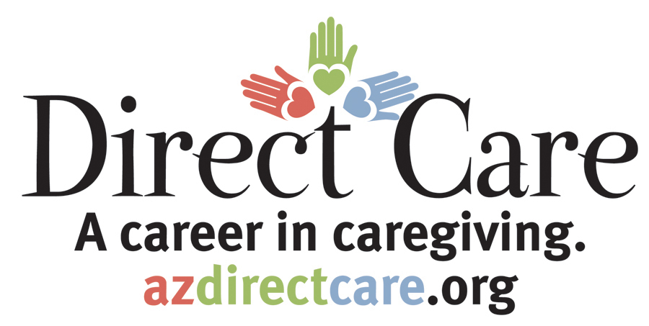
Arizona
Direct Care Worker
Training

This certificate of completion is awarded to

Level 1: Fundamentals

By:

Instructor |  | Date

